I.L. Motorsport Installation guide
- MX-5 Rear Adjustable Toe Arm 2 Piece Set - ND0-301139
- MX-5 Rear Adjustable Traction Arm - ND0-301138

SUBFRAME
Optional: welding of metal plates on subframe suspension assembly (recommended for racing use)
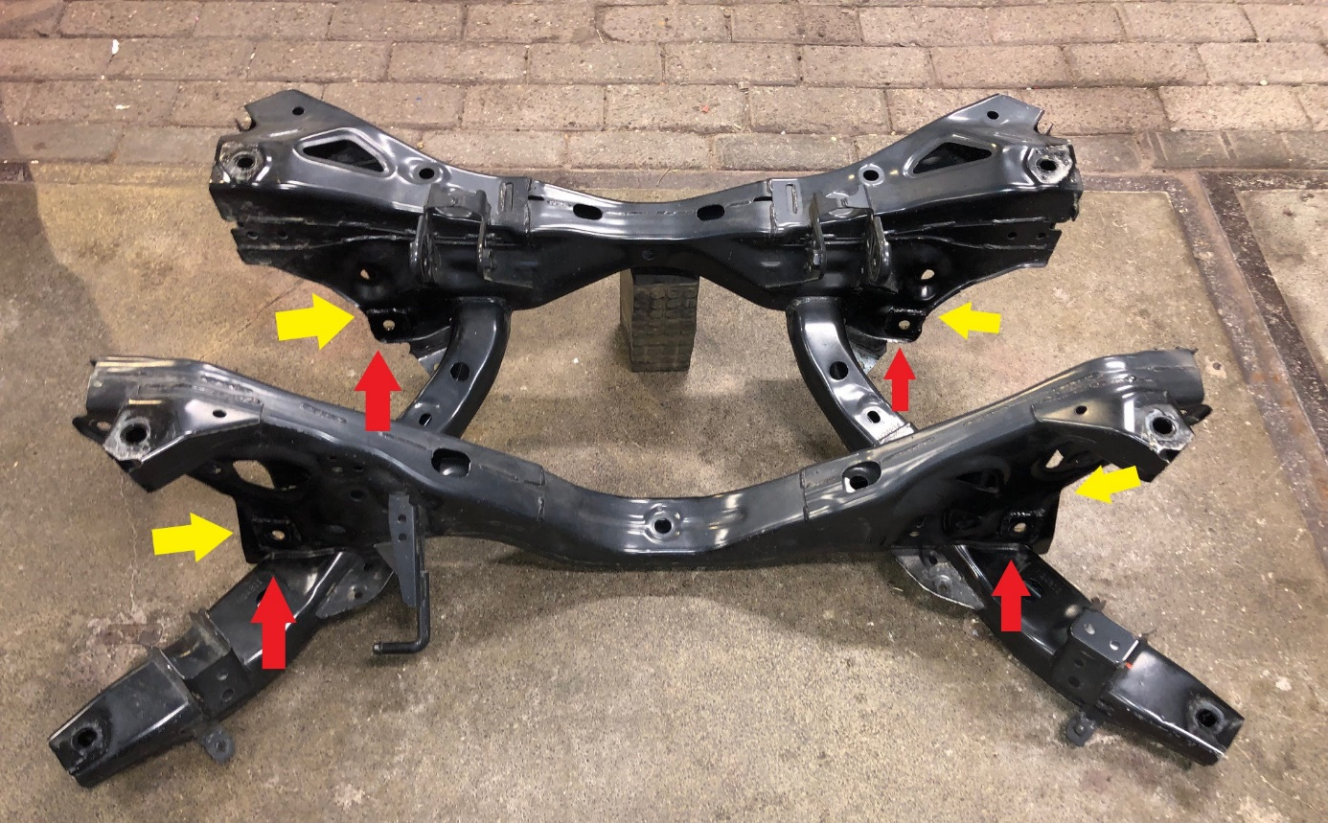
Picture 1: position of metal plates on subframe.
There are four points where the suspension arms are connected to the subframe. Each of these have two holes for the suspension arm bolt. In total, these are 8 holes that need to be covered with the metal plate and welded in place. The red arrows show the visible plates, the yellow arrows indicate the location of the plates on the opposite side. 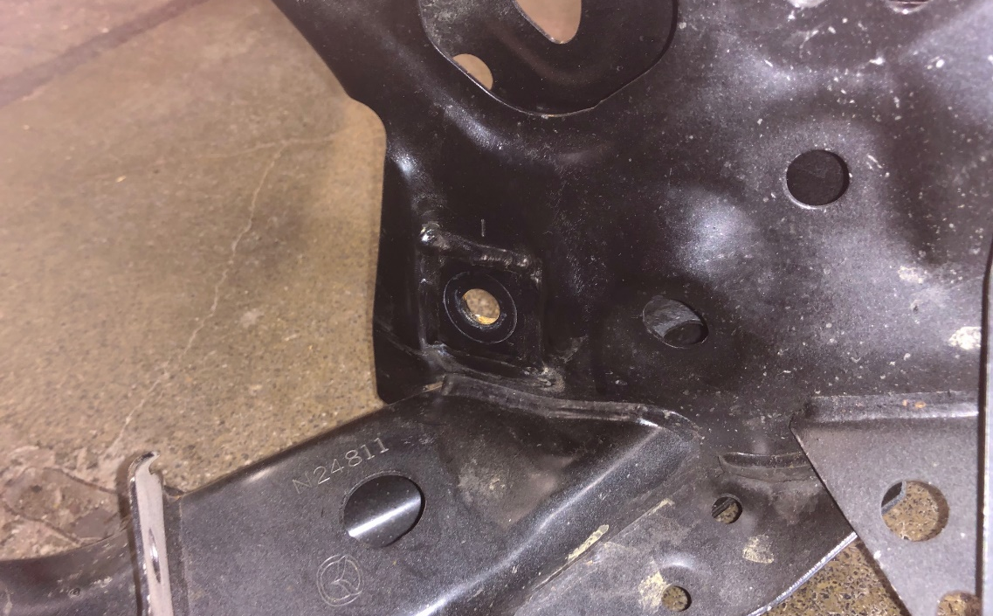
Picture 2: welded plate on subframe
DISASSEMBLY
Remove the original suspension arms
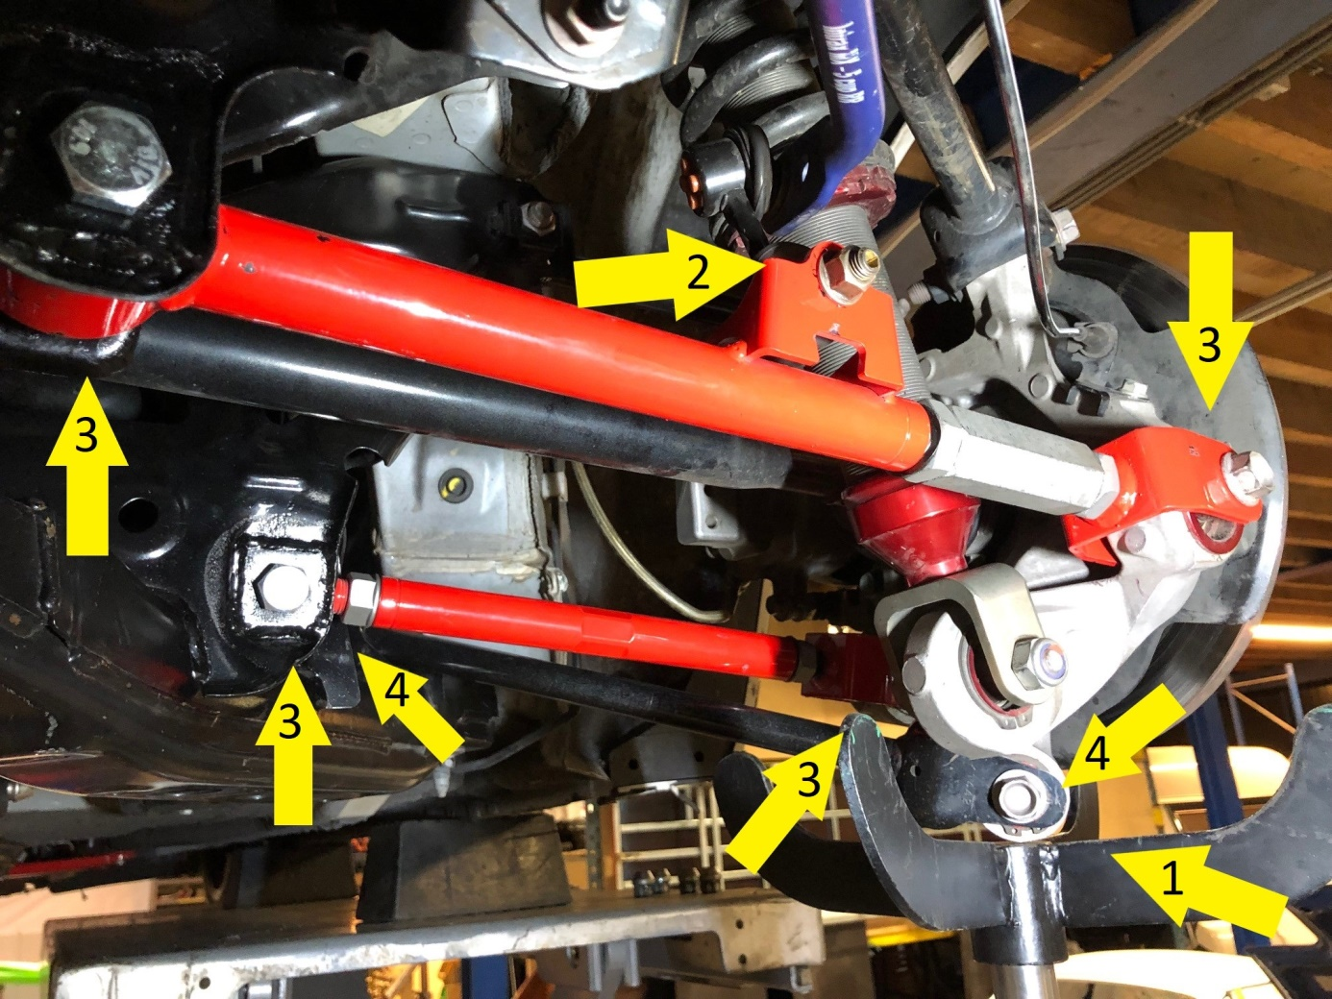
Picture 3: lower suspension arms removal, showing already installed new suspension arms. Original ones will be black instead of red.

Start with removing the existing front and rear suspension arm bolts (picture 3). Note the above picture does not show the original arms just the location of the bolts.
- Remove the wheel and support the knuckle to prevent it from falling down as the suspension arms are removed (for example with an axle stand)
- Remove the ARB bolts and disconnect the ARB
- Remove the suspension arm bolts
- Remove the bolts of the remaining lower suspension arm.

Then remove the knuckle bolt of the upper rear suspension arm (picture 4).
- Remove the knuckle bolt of the upper rear suspension arm.
Note that it is not required to remove the final upper suspension arm.
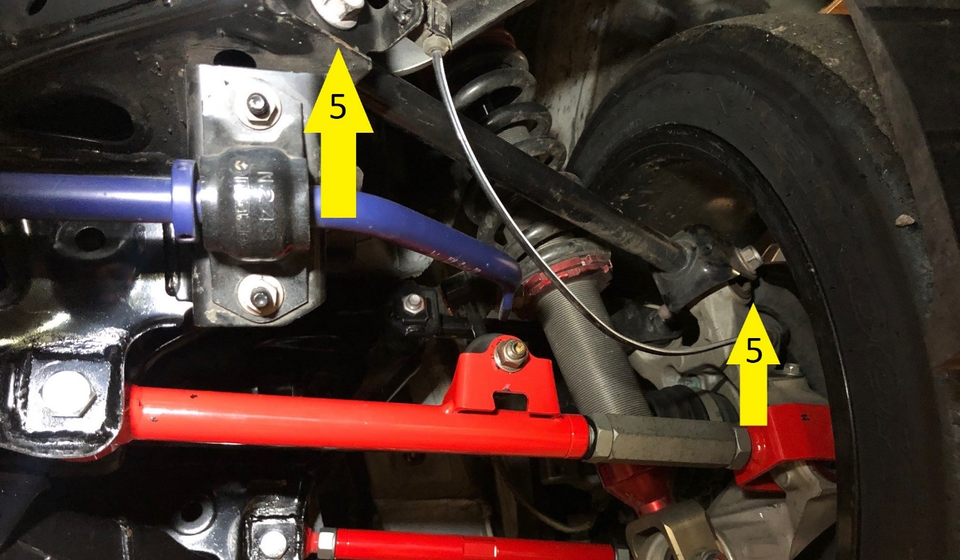
Picture 4: remove upper suspension arm

ASSEMBLY
Install the new suspension arms
Before placing the new suspension arms, adjust the length of the arms to roughly the same as the OEM black arms to aid alignment. Note that it could be useful to change the arm length during assembly for convenience of installation.

If you have welded plates to the subframe as per picture 1 the OEM alignment bolts will no longer fit (too short), but in all cases we recommended to replace the alignment bolts with the bolts as supplied in the complete kit. (picture 6)
- Install the non-OEM bolts on the location where the alignment bolts used to be.

Replace removed suspension arms with new suspension arms, re-attach bolts 2/3/4/5 and the ARB (picture 3 and 4) to complete process.

Note that your car’s alignment will have changed after installation. A re-alignment is required.
Enjoy the ease of use now of the adjustment on the control arms!

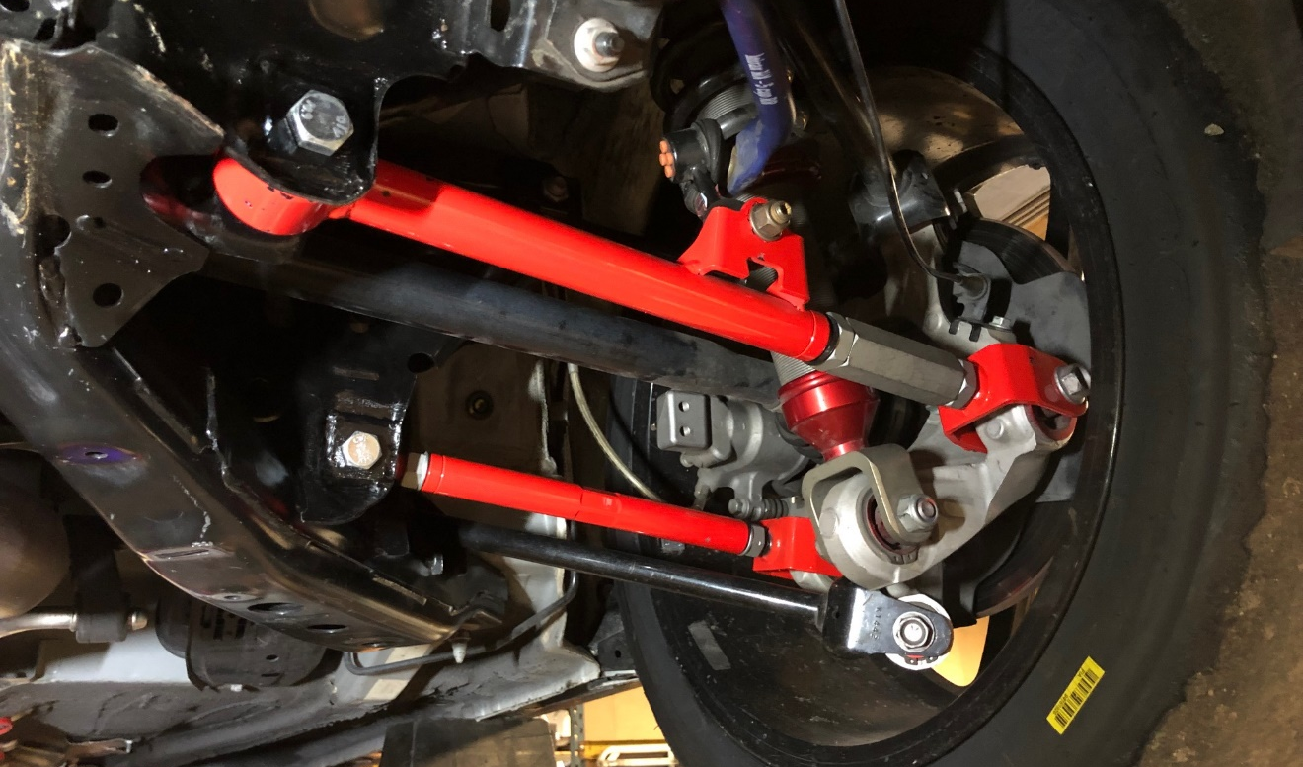Picture 5: final assembly with the suspension arms in place
6
6

